Mandatory Sign
All the compulsory signs are indicated in a circular form. The violation of traffic or road regulations indicated buy these signs is a legal offence !
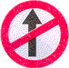 | 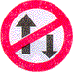 | 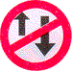 | 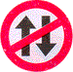 | 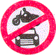 | 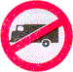 | 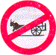 | 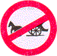
No Entry | One Way | One Way | Vehicle Prohibited in both directions | All motor vehicles prohibited | Truck prohibited | Bullock cart prohibited | Tonga prohibited
 | 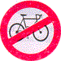 | 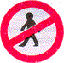 | 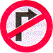 | 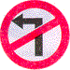 | 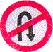 |  | 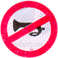
Hand cart prohibited | Cycle prohibited | Pedestrians prohibited | Right turn prohibited | Left turn prohibited | U-turn prohibited | Overtaking prohibited | Horn prohibited
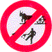 | 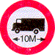 | 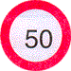 | 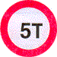 | 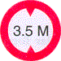 | 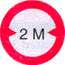 | 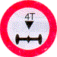 | 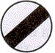
Bullock cart & cart prohibited | Length limit | Speed limit | Load limit | Height limit | Width limit | Axle load limit | Restriction ends sign
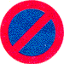 |  |  |  |  |  | 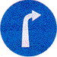 | 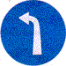
No parking | No stopping or standing | Compulsory ahead only | Compulsory keep left | Compulsory turn left | Compulsory turn right | Compulsory right ahead | Compulsory turn left ahead
 |  | 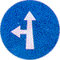
 |  | Compulsory ahead or turn left | Compulsory ahead or turn right | Compulsory cycle track | Compulsory sound horn
Warning Sign
These are signs indicated in a triangular form. They are meant for the safety of the road user :
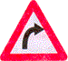 | 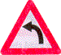 | 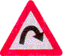 | 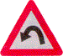 | 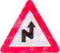 | 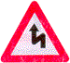 | 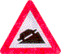 | 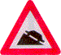
Right hand curve | Left hand curve | Hair pin bend right | Hair pin bend left | Right reverse bend | Left reverse bend | Steep ascent | Steep decent
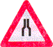 | 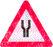 | 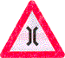 | 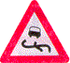 | 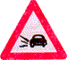 | 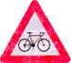 | 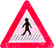 | 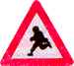
Narrow road ahead | Wide road ahead | Narrow bridge | Slippery road | Loose gravel | Cycle crossing | Pedestrian crossing | School ahead
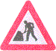 | 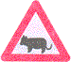 | 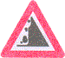 | 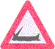 | 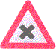 | 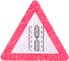 | 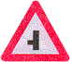 | 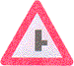
Men at work | Cattle | Falling rocks | Ferry | Cross road | Gap in median | Side road left | Side road right
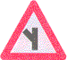 | 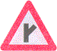 | 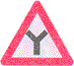 | 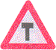 | 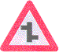 | 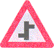 | 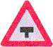
Y-intersection | Y-intersection | Y-intersection | Y-intersection | Staggered intersection | Staggered intersection | Major road ahead | Major road ahead
 | 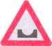 | 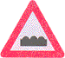 | 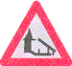 | 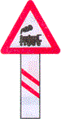 | 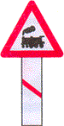 | 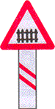 | 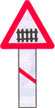
Roundabout | Dangerous dip | Hamp or rought road | Barrier ahead | 200 metres ahead | 50-100 metres in plain and rolling terrain and 30-60 metres in hilly terrain | 200 metres ahead | 50-100 metres in plain and rolling terrain and 30-60 metres in hill terrain

Informatory Signs
These gives you information about such things as high way facilities, parking facilities etc and you can recognise them from their blue backround.
Public telephone | Petrol pump | Hospital | First aid post | Eating place | Light refreshment | Resting place | No thorough road
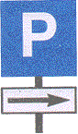 |  |  |  |  | 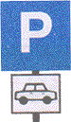
Park this side | No thorough side road | Parking both sides | Scooter and motorcycle stand | Cycle stand | Taxi stand | Auto rickshaw stand
Type of Line markings on the Road
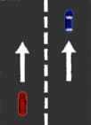 |  | 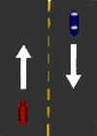 |  | 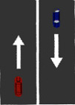 |  | 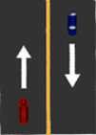
Separation of lanes on which travel is in the same direction, woth crossing from one of the other permitted. |  | Separation of lanes on which travel is in the opposite direction, and where overtaking with care is permitted. |  | Separation of lanes or of a lane and shoulder where lane changing is discouraged. |  | This line is found on busy main roads and traffic intersection. Here crossing this line and overtaking is prohibited
 |  | 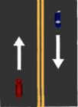 |  | 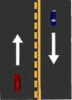
 |  | Separation of lanes where overtaking is prohibited in both directions. Right turn monoeuvres across this marking are not permitted. |  | Separation of lanes where overtaking is permitted with care for traffic adjacent to the broken line, but prohibited for traffic adjacent to solid line.

